Babin Rana
Lab 1

Q1. Create a Simple Website Titled Introduction to HTML. Add a large heading using <h1>tag titled HTML Basics. Use <h2> tags for section heading. Create 2 section headings: Use of <p> tag and User of <pre> tag. Under these headings show the use case of <p> and <pre> tags.

Code:
<!DOCTYPE html>
<html lang="en">
<head>
<meta charset="UTF-8">
<meta name="viewport" content="width=device-width, initial-scale=1.0">
<title>Question 1</title>
</head>
<body>
<h1>HTML Fundamentals</h1>

<h2>Using the &lt;p&gt; Tag</h2>
<p>The &lt;p&gt; tag is crucial for defining paragraphs in HTML. It creates a block-level element that adds space before and after the text, enhancing readability. Here is an example of a paragraph:</p>
<p>This is a sample paragraph created using the &lt;p&gt; tag. Notice how the browser automatically adds space around this block of text.</p>

<h2>Using the &lt;pre&gt; Tag</h2>
<p>The &lt;pre&gt; tag is used to define preformatted text. Text within this tag is displayed in a fixed-width font, and white spaces, line breaks, and formatting are preserved. Here is an example:</p>
<pre>
This is a sample of preformatted text.
Line breaks and spaces are preserved.
Useful for displaying code snippets or text with specific formatting.
</pre>
</body>
</html>

Output:
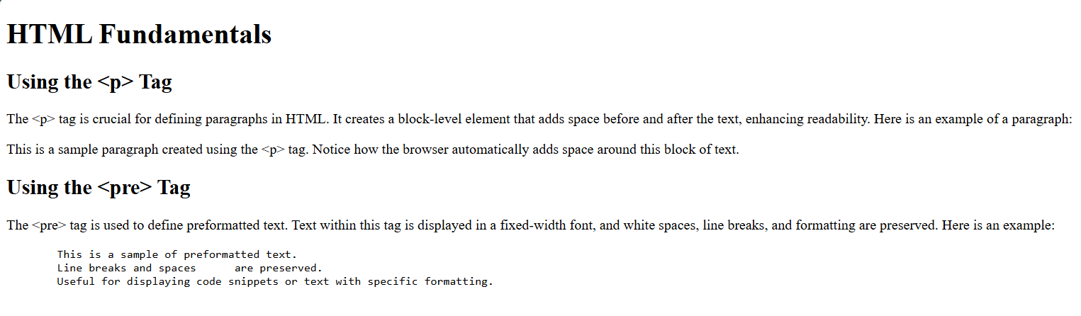

Q2. Create a webpage with a HTML table showcasing different projects chosen by students. Student
Columns:
a. S.N
b. Project Name
c. Student Name
d. Exam Roll Number
e. Remarks
Use thead, tbody and tfoot. Use border attribute to have 2 table borders. Use rowspan and colspan in
the necessary areas. The table should have at least 4 projects involving 7 students

Code:
<!DOCTYPE html>
<html lang="en">
<head>
<meta charset="UTF-8">
<meta name="viewport" content="width=device-width, initial-scale=1.0">
<title>Question 2</title>
</head>
<body>
<h1>Student Projects Table</h1>
<table border="2">
<thead>
<tr>
<th>S.N</th>
<th>Project Name</th>
<th>Student Name</th>
<th>Exam Roll Number</th>
<th>Remarks</th>
</tr>
</thead>
<tbody>
<tr>
<td rowspan="2">1</td>
<td rowspan="2">Science</td>
<td>Raka</td>
<td>101</td>
<td rowspan="2">Excellent</td>
</tr>
<tr>
<td>Avilasha</td>
<td>102</td>
</tr>
<tr>
<td>2</td>
<td>Mathematics</td>
<td>Roshan</td>
<td>103</td>
<td>Good</td>
</tr>
<tr>
<td>3</td>
<td rowspan="2">Social Studies</td>
<td>Ram</td>
<td>104</td>
<td>Very Good</td>
</tr>
<tr>
<td>4</td>
<td>Rajan</td>
<td>105</td>
<td>Good</td>
</tr>
<tr>
<td>5</td>
<td>Nepali</td>
<td>Bhunti</td>
<td>106</td>
<td>Outstanding</td>
</tr>
</tbody>
<tfoot>
<tr>
<td colspan="5">Projects with their details</td>
</tr>
</tfoot>
</table>
</body>
</html>

Output:
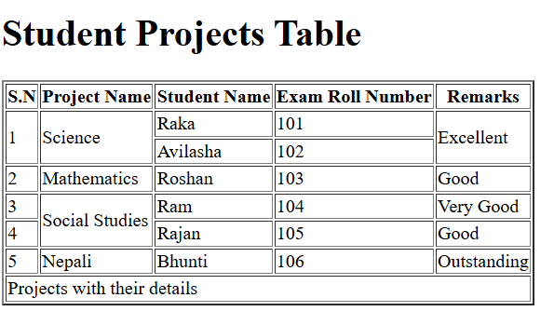

Q3. Create a search bar using get method
Code:
<!DOCTYPE html>
<html lang="en">
<head>
<meta charset="UTF-8">
<meta name="viewport" content="width=device-width, initial-scale=1.0">
<title>Search Bar</title>
</head>
<body>

<h2>Search Bar</h2>
<form method="post" action="/search">
<label for="query">Search:</label>
<input type="text" id="query" name="query" placeholder="Type Here!">
<button type="submit">Search</button>
</form>

</body>
</html>

Outptut:
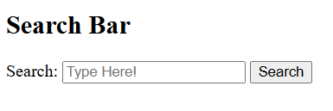

Q4. Create a User Registration form with following details.
a. Name
b. Email
c. Password
d. Gender (Radio Button)
e. Hobbies (Checkbox)
f. Submit button

Code:
<!DOCTYPE html>
<html lang="en">
<head>
<meta charset="UTF-8">
<meta name="viewport" content="width=device-width, initial-scale=1.0">
<title>Introduction to HTML</title>
</head>
<body>

<h2>User Registration Form</h2>
<form method="post" action="/register">
<label for="name">Name:</label>
<input type="text" id="name" name="name" placeholder="Enter your name" required><br><br>

<label for="email">Email:</label>
<input type="email" id="email" name="email" placeholder="Enter your email" required><br><br>

<label for="password">Password:</label>
<input type="password" id="password" name="password" placeholder="Enter your password" required><br><br>

<label>Gender:</label>
<input type="radio" id="male" name="gender" value="male" required>
<label for="male">Male</label>
<input type="radio" id="female" name="gender" value="female" required>
<label for="female">Female</label><br><br>

<label>Hobbies:</label>
<input type="checkbox" id="Dance" name="hobbies" value="Dance">
<label for="Dance">Dance</label>
<input type="checkbox" id="Football" name="hobbies" value="Football">
<label for="Football">Football</label>
<input type="checkbox" id="Singing" name="hobbies" value="Singing">
<label for="Singing">Singing</label><br><br>

<button type="submit">Submit</button>
</form>

</body>
</html>

Output:
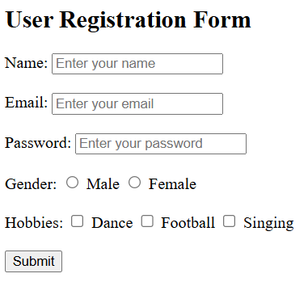

Q5.Create a webpage titled Top 3s trekking destinations in Nepal. Add a heading using <h1> tag. Insert images of 3 popular destinations in the webpage. Use caption tag to label these images. Make use of alt for each images of equal width 300px.

Code:
<!DOCTYPE html>
<html lang="en">
<head>
<meta charset="UTF-8">
<meta name="viewport" content="width=device-width, initial-scale=1.0">
<title>Top 3 Trekking Destinations in Nepal</title>
</head>
<body>
<h1>Top 3 Trekking Destinations in Nepal</h1>

<figure>
<img src="ebc.jpg" alt="Everest Base Camp" width="300">
<figcaption>Everest Base Camp</figcaption>
</figure>

<figure>
<img src="abc.jpg" alt="Annapurna Circuit" width="300">
<figcaption>Annapurna Circuit</figcaption>
</figure>

<figure>
<img src="langtang.jpg" alt="Langtang Valley Trek" width="300">
<figcaption>Langtang Valley Trek</figcaption>
</figure>
</body>
</html>

Output:
